Air filtration:

We have planned to make our drone to purify the polluted air automatically. Our main object is to provide the clean air to the folks. The atmosphere of our surroundings has become very much polluted. So, we tend to don’t purify all of that big amounts. Besides we tend to concentrate on supply clean air with help of drone’s motor. This drone is used as double fan structure. We will place the filter on the top of it. There would be air filter s between each fan which will help to purify the air.

# PP214 Air Filter Kit

# There are several air filters found in market. World Marketing PP214 Air Filter Kit for Reddy Heaters is one of them. This is very small in size, easy to collaborate with Drone and light weight.

# 

# Fig:1 PP214 Air Filter Kit.

# Specification:

* Reddy heater air filter Kit
* Includes M11637 lint filter, M12179 INTAKE filter, M5115001 fuel filter & M122441 output filter
* Manufactured in China
* Package dimensions : 2.0 inches (H) x 7.0 inches (L) x 5.0 inches (W)

**Mann-Filter CUK 4436 Cabin Filter With Activated Charcoal for select Mini models**

|  |  |
| --- | --- |
| Manufacturer | Mann-Filter |
| Brand | Mann Filter |
| Item Weight | 0.01 ounces |
| Product Dimensions | 4.92 x 1.46 x 17.91 inches |
| Item model number | CUK 4436 |
| Is Discontinued By Manufacturer | No |
| Manufacturer Part Number | CUK4436 |
| [OEM Part Number](https://www.amazon.com/gp/jewelry/technical-specs-help/?ie=UTF8&hideLogo=1&page_ident=1000627391) | Corteco 80000741, Febi Bilstein 28379, Mahle Original LAK 385, Vemo V20-31-1012, Mahle LAK 385, Meyle 312 320 0009, Magneti Marelli 350203062470, Hengst Filter E2947LC, Filtron K1239A |
| [Folding](https://www.amazon.com/gp/jewelry/technical-specs-help/?ie=UTF8&hideLogo=1&page_ident=1000627441) |  |

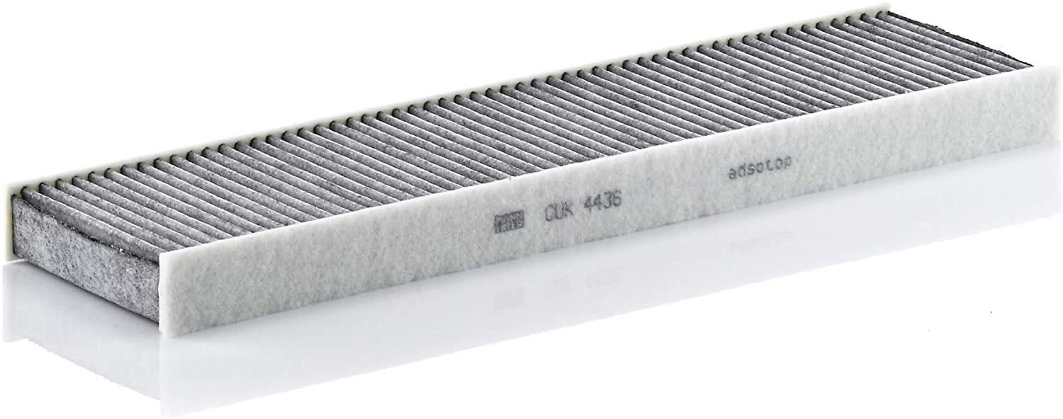

Fig :2  Mann-Filter CUK 4436 Cabin Filter With Activated Charcoal.

**Advantages:**

* Filters out pollen, spores, dust and harmful gases
* Optimum ventilation inside the vehicle through low flow resistance
* Consistent filtration performance throughout the entire service interval
* Exact fit and seal
* Greatest filtration efficiency through a combination of mechanical and electrostatic attraction

Reference:

1. <https://www.amazon.com/World-Marketing-PP214-Filter-Heaters/dp/B0030BBD4S/ref=asc_df_B0030BBD4S/?tag=bingshoppinga-20&linkCode=df0&hvadid=&hvpos=&hvnetw=o&hvrand=&hvpone=&hvptwo=&hvqmt=e&hvdev=c&hvdvcmdl=&hvlocint=&hvlocphy=&hvtargid=pla-4583726540582667&psc=1>
2. <https://www.amazon.com/Mann-Filter-CUK-4436-Filter-Activated/dp/B00252KEHK/ref=sr_1_3?dchild=1&keywords=air+filter+mini+size&qid=1594323995&sr=8-3>